E-Governance Grievance Redressal System

DOCUMENT CONTROL

Item | Details
Project Name | E-Governance Grievance Redressal System
Author | Aryan , Himanshu, Debarghya, Yati, Kanchan
Date | (Date)
Status | Working

PURPOSE OF THE DOCUMENT
This document describes the system architecture, design decisions, component structure, APIs, data models, and non-functional aspects of the Smart Order Management System.
It is intended for:
- Developers
- Reviewers
- Interview discussions
- Maintenance & enhancement planning
SYSTEM OVERVIEW

Business Objective
Provide a scalable, secure, and maintainable E-Governance platform to:
- Enable citizens to register and track grievances digitally
- Ensure accountability by assigning grievances to relevant departments
- Monitor grievance lifecycle and resolution timelines
- Improve transparency through centralized tracking and notifications
- Support future growth using a microservices-based architecture
Business Rules

- Only authenticated users with valid roles can access system features, enforced through JWT-based role authorization.
- Citizens are the only users permitted to lodge grievances, and each grievance must be associated with exactly one category and department.
- Every grievance is assigned a unique system-generated grievance ID and timestamp at the time of submission.
- Grievances follow a strictly enforced lifecycle: Submitted → Assigned → In Review → Resolved → Closed, with no status skipping allowed.
- Grievances are automatically routed to the appropriate department based on category-to-department mapping.
- Only authorized department officers can update grievance status and submit resolution remarks.
- A grievance is eligible for escalation if it remains unresolved beyond a predefined resolution timeframe.
- Citizens may submit feedback and ratings only after a grievance has been resolved, with limited scope for reopening.
- Administrative and supervisory users have read-only access to analytics and performance reports derived from grievance data.
- All grievance actions, status changes, and resolutions are logged with timestamps to ensure transparency, traceability, and auditability.

High-Level Features
- Citizen registration and secure login using JWT authentication
- Online grievance lodging with description and document/image upload
- Centralized grievance tracking with unique reference ID (PNR-like)
- Grievance lifecycle management: Submitted → Assigned → In Review → Resolved → Closed/Withdrawn
- Automatic or manual department assignment for accountability
- Role-based dashboards and access control (Citizen / Officer / Supervisor / Admin)
- Status change notifications via notification service
- Escalation of grievances if not resolved within defined time limits
- Feedback submission by citizens after grievance resolution
- Reports and analytics for department-wise and category-wise performance

FLOW:
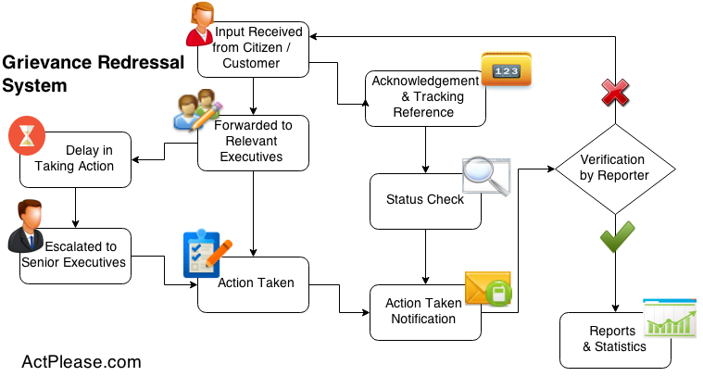

PAGES/FEATURES
Login page
Register Page
Home Page
Issues register page (Document / image upload) AI for category assigning on description
View status (Submitted → Assigned → In Review → Resolved → Closed/Withdraw)
Issue page (open + closed - tabs)
Profile page (adhaar card, name)
Feedback page (after resolution - customer can give feedback)
Mail system - notification service
Escalations - time period mai resolve nhi hua to escalate to higher authorities
Contact Us Page
Mandatory Pages
- Different frontend for different roles (for efficient scaling)

System Admin | Department Officer | Supervisory Officer | Citizen
Login (backend) | Login (initial mail) | Login (initial mail) | Login / Register
 |  |  | Lodge Grievance
 |  |  | My Grievances
Grievance Details | Grievance Details | Grievance Details | Grievance Details
 | Reports  (By Assigned Category) | Reports  (By Category)
Admin Panel
 |  |  | Citizen Dashboard - Citizen
Officer Dashboard | Officer Dashboard (By Assigned Category) | Officer Dashboard  (By Category)

Core Components/ Pages
● Login / Register - User
● Citizen Dashboard - Citizen
● Lodge Grievance
● My Grievances
● Grievance Details
● Officer Dashboard
● Reports
● Admin Panel

Optional:

FAQ

Possible Department Examples:
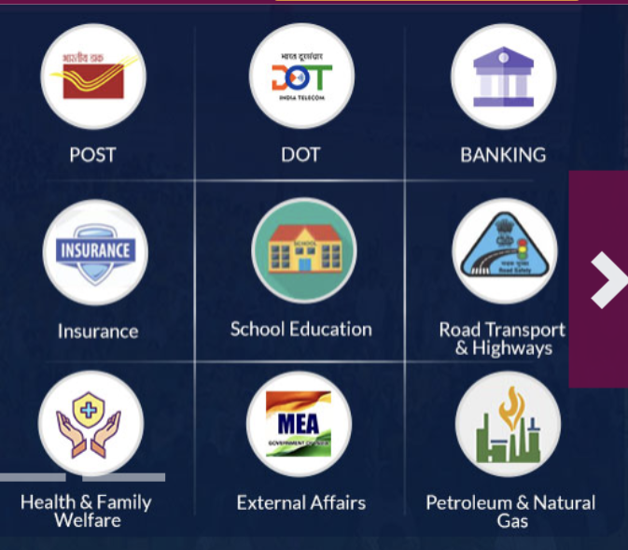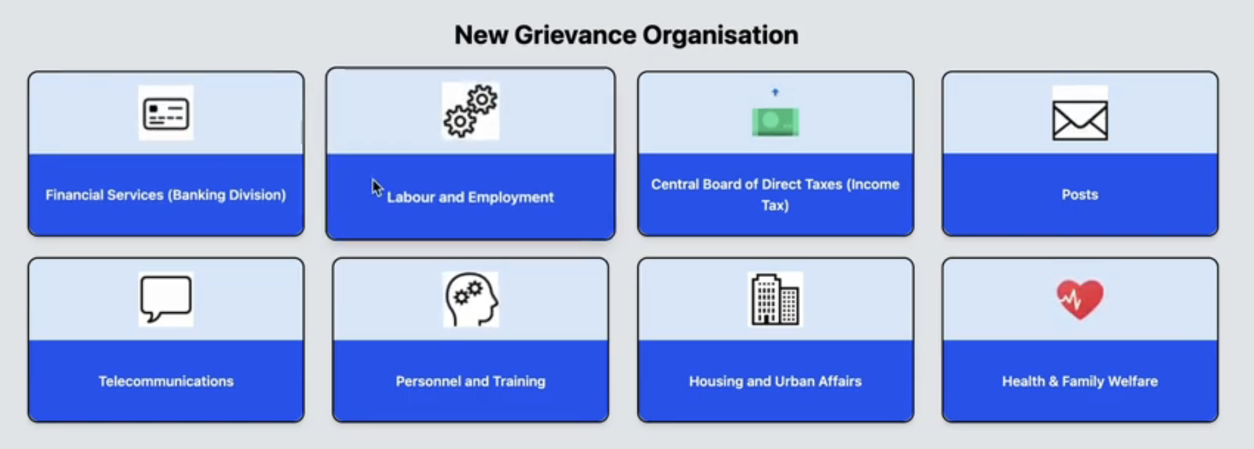

ROLES

1. System Admin (CM/PM): Manage departments, grievance categories, users, and roles

2. Department Officer: View and resolve assigned grievances

3. Supervisory Officer (Department Head): Monitor grievance status and escalations

4. Citizen: Register, submit grievances, and track status

Architecture Diagram:

ER Diagram:

MicroServices

- API GATEWAY
- Security Service (id,full_name, aadhaar_number, email, password_hash, role, phone)
- Config Server
- Grievance Service (id, grievance_number, citizen_id, department_id,title, description, status, assigned_officer_id)
- Notification service (id, user_id, subject, message)
- Department Service (id, name, description)
- Feedback Service (id, grievance_id, citizen_id, comment)
- Storage Service (id, grievance_id, file_name, file_data)

Optional: Workflow/Resolution Service

Endpoints

- Security Service /User Service

Authentication & Security Service APIs
HTTP Method | Endpoint | Description | Access Role | Notes
POST | /auth/register | Register a new user | Citizen / Admin | Department account creation via request header
POST | /auth/login | Authenticate user and issue JWT | All Users | Returns JWT token
POST | /auth/logout | Logout user | Authenticated User | Invalidates session/token
GET | /auth/validate | Validate JWT token | Internal / Gateway | Used by API Gateway
POST | /auth/change-password | Change account password | Authenticated User | Requires old password
POST | /auth/forgot-password | Initiate password reset | All Users | Sends reset link/OTP

User Service APIs
HTTP Method | Endpoint | Description | Access Role | Notes
GET | /users | Fetch all users | Admin | Supports pagination
GET | /users/{userId} | Fetch user details by ID | Admin, Self | Restricted access
PUT | /users/{userId} | Update user profile | Admin, Self | Profile information only
DELETE | /users/{userId} | Delete / deactivate user | Admin | Soft delete recommended

Role & Department Mapping APIs
HTTP Method | Endpoint | Description | Access Role | Notes
GET | /users/by-role/{role} | Get users by role | Admin | Example: CITIZEN, OFFICER
GET | /users/by-department/{departmentId} | Get users by department | Admin | Used for officer assignment
PUT | /users/{userId}/role | Assign or update user role | Admin | Role-based access enforced
PUT | /users/{userId}/department | Assign user to department | Admin | Mandatory for officers

- Department Service -

Method | Endpoint | Role | Description
GET | /departments | Public | Get All Departments (for Dropdowns/Filters).
POST | /departments | Admin | Create a new Department.
GET | /departments/{id} | Public | Get Single Department details.
PUT | /departments/{id} | Admin | Update Department details.
DELETE | /departments/{id} | Admin | Soft delete a department.
POST | /departments/{id}/officers | Supervisor | Assign an existing User to this Department (as Officer).
GET | /departments/{id}/officers | Supervisor | List officers specifically for this department.
GET | /departments/{id}/categories | Public | Get categories (e.g., Water -> "Pipe Leak", "Bad Quality").
POST | /departments/{id}/categories | Admin | Add a new grievance category.
GET | /departments/categories | Public | Flat list of all categories (for Search).

3. Grievance Service
Handles the lifecycle: Submitted → Assigned → In Review → Resolved.

HTTP Method | Endpoint | Description | Access Role | Notes
POST | /grievances | Lodge a new grievance | Citizen | Generates a unique grievance ID (PNR-like)
GET | /grievances/my-grievances | List grievances of logged-in citizen | Citizen | Supports pagination
GET | /grievances | List all grievances | Admin, Supervisor | Supports filters like ?status=PENDING&deptId=2
GET | /grievances/{id} | Get full details of a grievance | Citizen, Officer, Admin, Supervisor | Access restricted to authorized users
PATCH | /grievances/{id}/assign/{officerId} | Assign grievance to an officer | Supervisor | Can be auto-assigned or manual
PATCH | /grievances/{id}/status | Update grievance status | Officer | Includes resolution remarks
POST | /grievances/{id}/comments | Add comment to grievance | Citizen, Officer | Supports clarification & discussion
GET | /grievances/{id}/comments | Fetch grievance comment history | Citizen, Officer | Used for chat-style UI

Status Update Request Body Example
{
"status": "RESOLVED",
"remarks": "Fixed the pothole."
}

Comment Request Body Example
{
"senderId": "user_001",
"role": "OFFICER",
"message": "Please provide the exact street name.",
"updateStatusTo": "CLARIFICATION_REQUIRED"
}

To track progress: - with detailed info
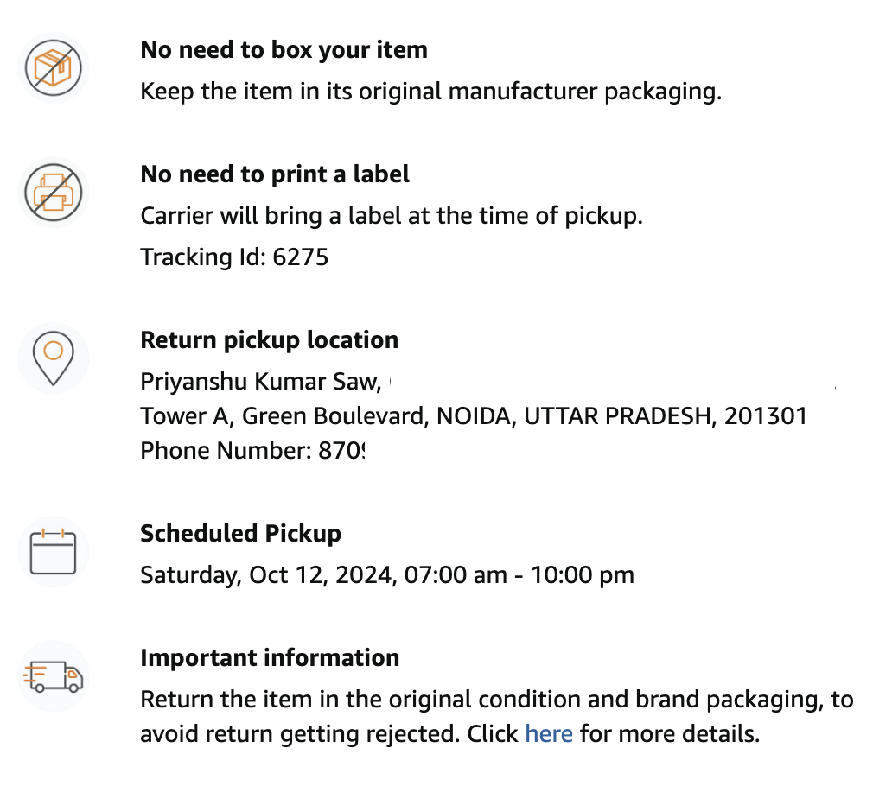

4. Feedback Service

(loop or only once - decide?)

Method | Endpoint | Role | Description
POST | /feedbacks | Citizen | Submit feedback. Check: If grievanceId already has feedback, throw Error.  Body: { "grievanceId": "123", "rating": 5, "comment": "Fast service!" }
GET | /feedbacks/grievance/{id} | Any | Check if feedback exists for a ticket.
GET | /feedbacks/average | Admin | Get average rating per department.  (for Admin Dashboard)

5. API Gateway

- /api/auth/** → Security Service

- /api/users/** → User Service

- /api/grievances/** → Grievance Service

- /api/departments/** → Department Service

- /api/feedbacks/** → Feedback Service

6. DepartmentService

Method | Endpoint | Role | Description
GET | / | Public/Auth | Get All Departments. Used to populate the "Select Department" dropdown on the frontend or filters on dashboards.
GET | /{id} | Public/Auth | Get Single Department. Returns details like name, description, and contact info.
POST | / | ADMIN | Create Department. Add a new department to the system.
PUT | /{id} | ADMIN | Update Department. Edit name or contact email.
DELETE | /{id} | ADMIN | Delete Department. (Soft delete recommended so old grievances don't break).
GET | /{id}/categories | Public/Auth | Get Categories by Dept. If user selects "Water Dept", call this to show ["Pipe Leak", "Low Pressure"].
POST | /{id}/categories | ADMIN | Add Category. Add a new issue type to a department.
GET | /categories | Public/Auth | Get All Categories. Flat list of all possible issues (useful for search).

7.Notification Service

Method | Endpoint | Role | Description
POST | /notifications/send | Internal | Manually trigger email/SMS.
GET | /notifications/my | Any | View notification history in the app.

Notification When?

i. User register
ii.password change
iii. Reset password
iv. status of grievance changes
Optional: Send Reminder

Additional Features
- Login/Get grievance detail pe trigger escalation if not done any status change in specified duration of time.
- Spam detection for grievance using AI
- Rewrite description using AI.

Non functional Requirements:
- RESTful API design
- Centralized exception handling
- Secure handling of citizen data
- Scalable and maintainable codebase

DATA DESIGN (LLD)

